**Kibana setup on local machine:**

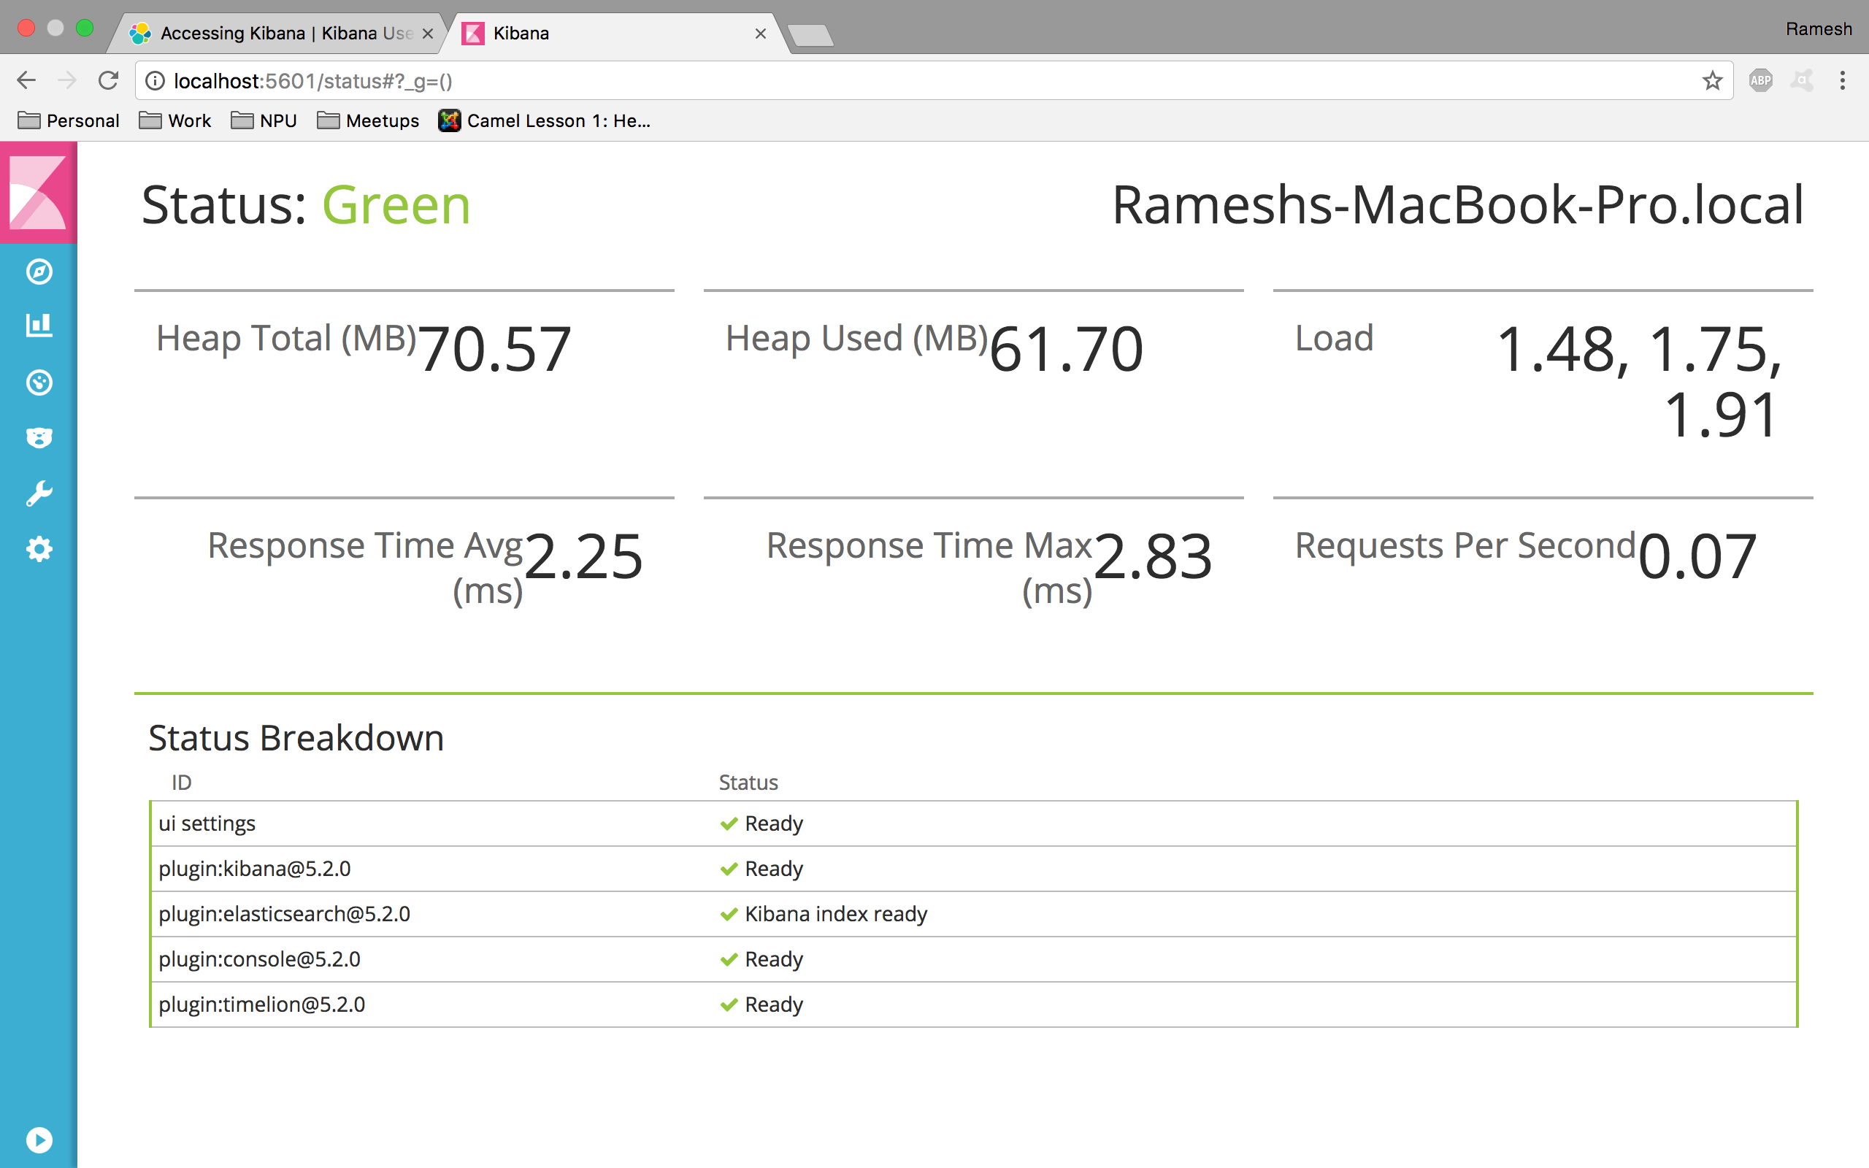

**Fetch all documents in all indices from elasticsearch server:**

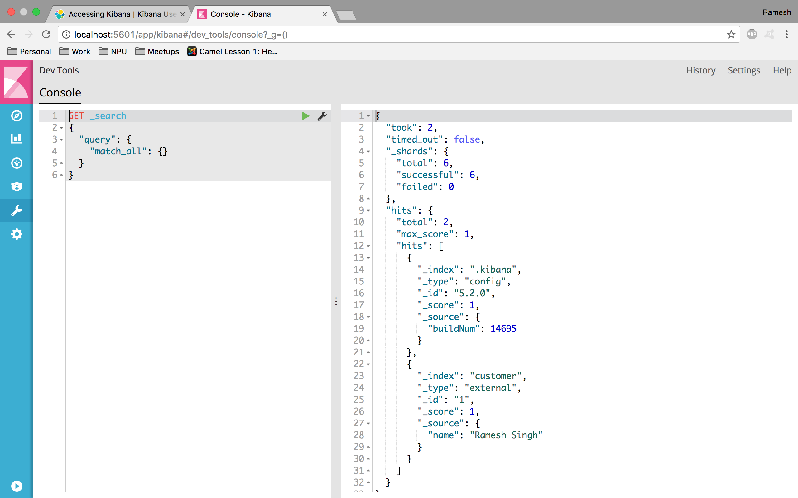

**Create Logstash Indices:**

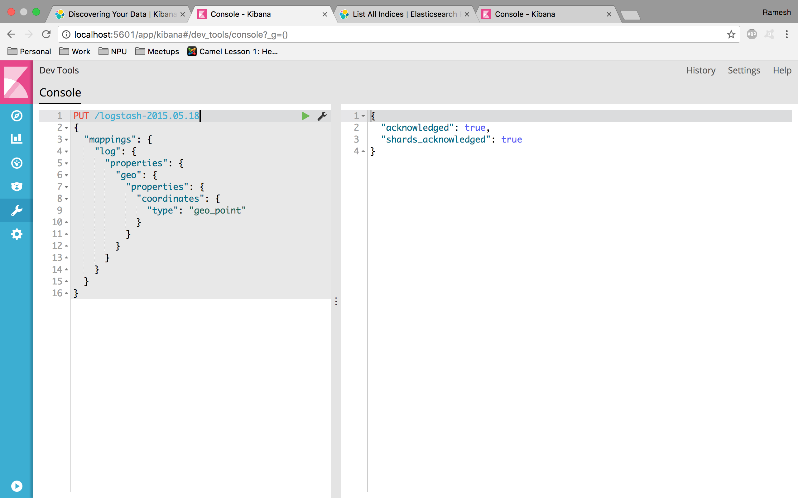

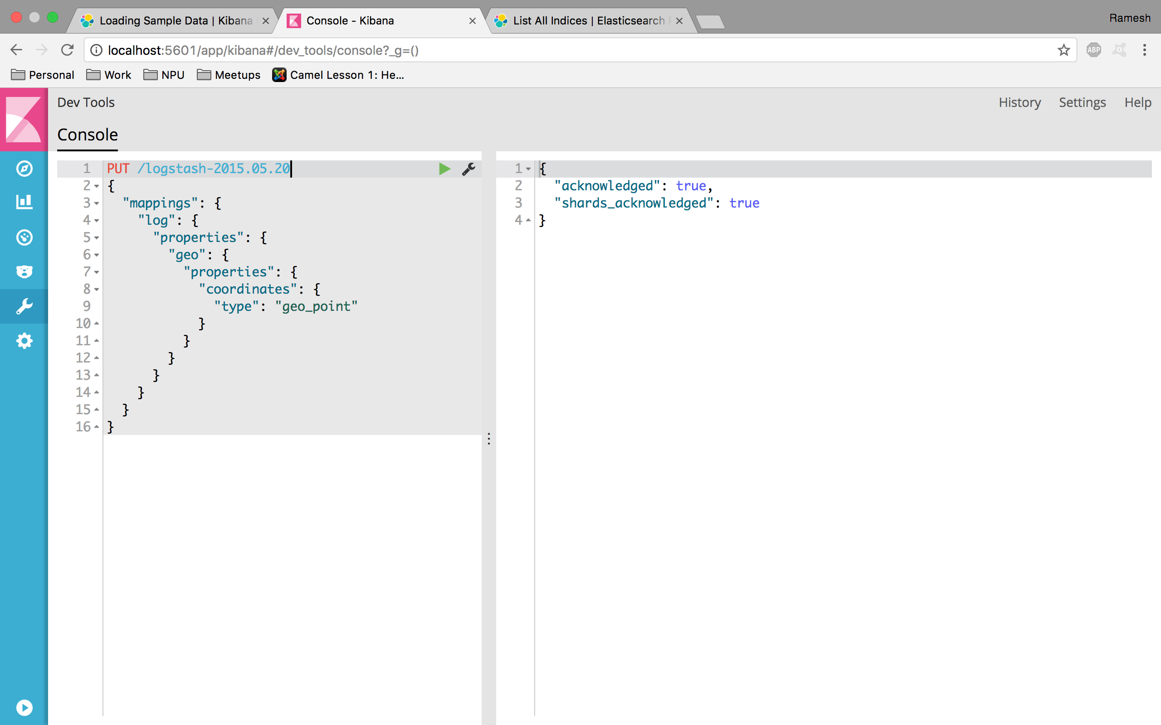

**Load account documents from JSON file in bank index using bulk API:**

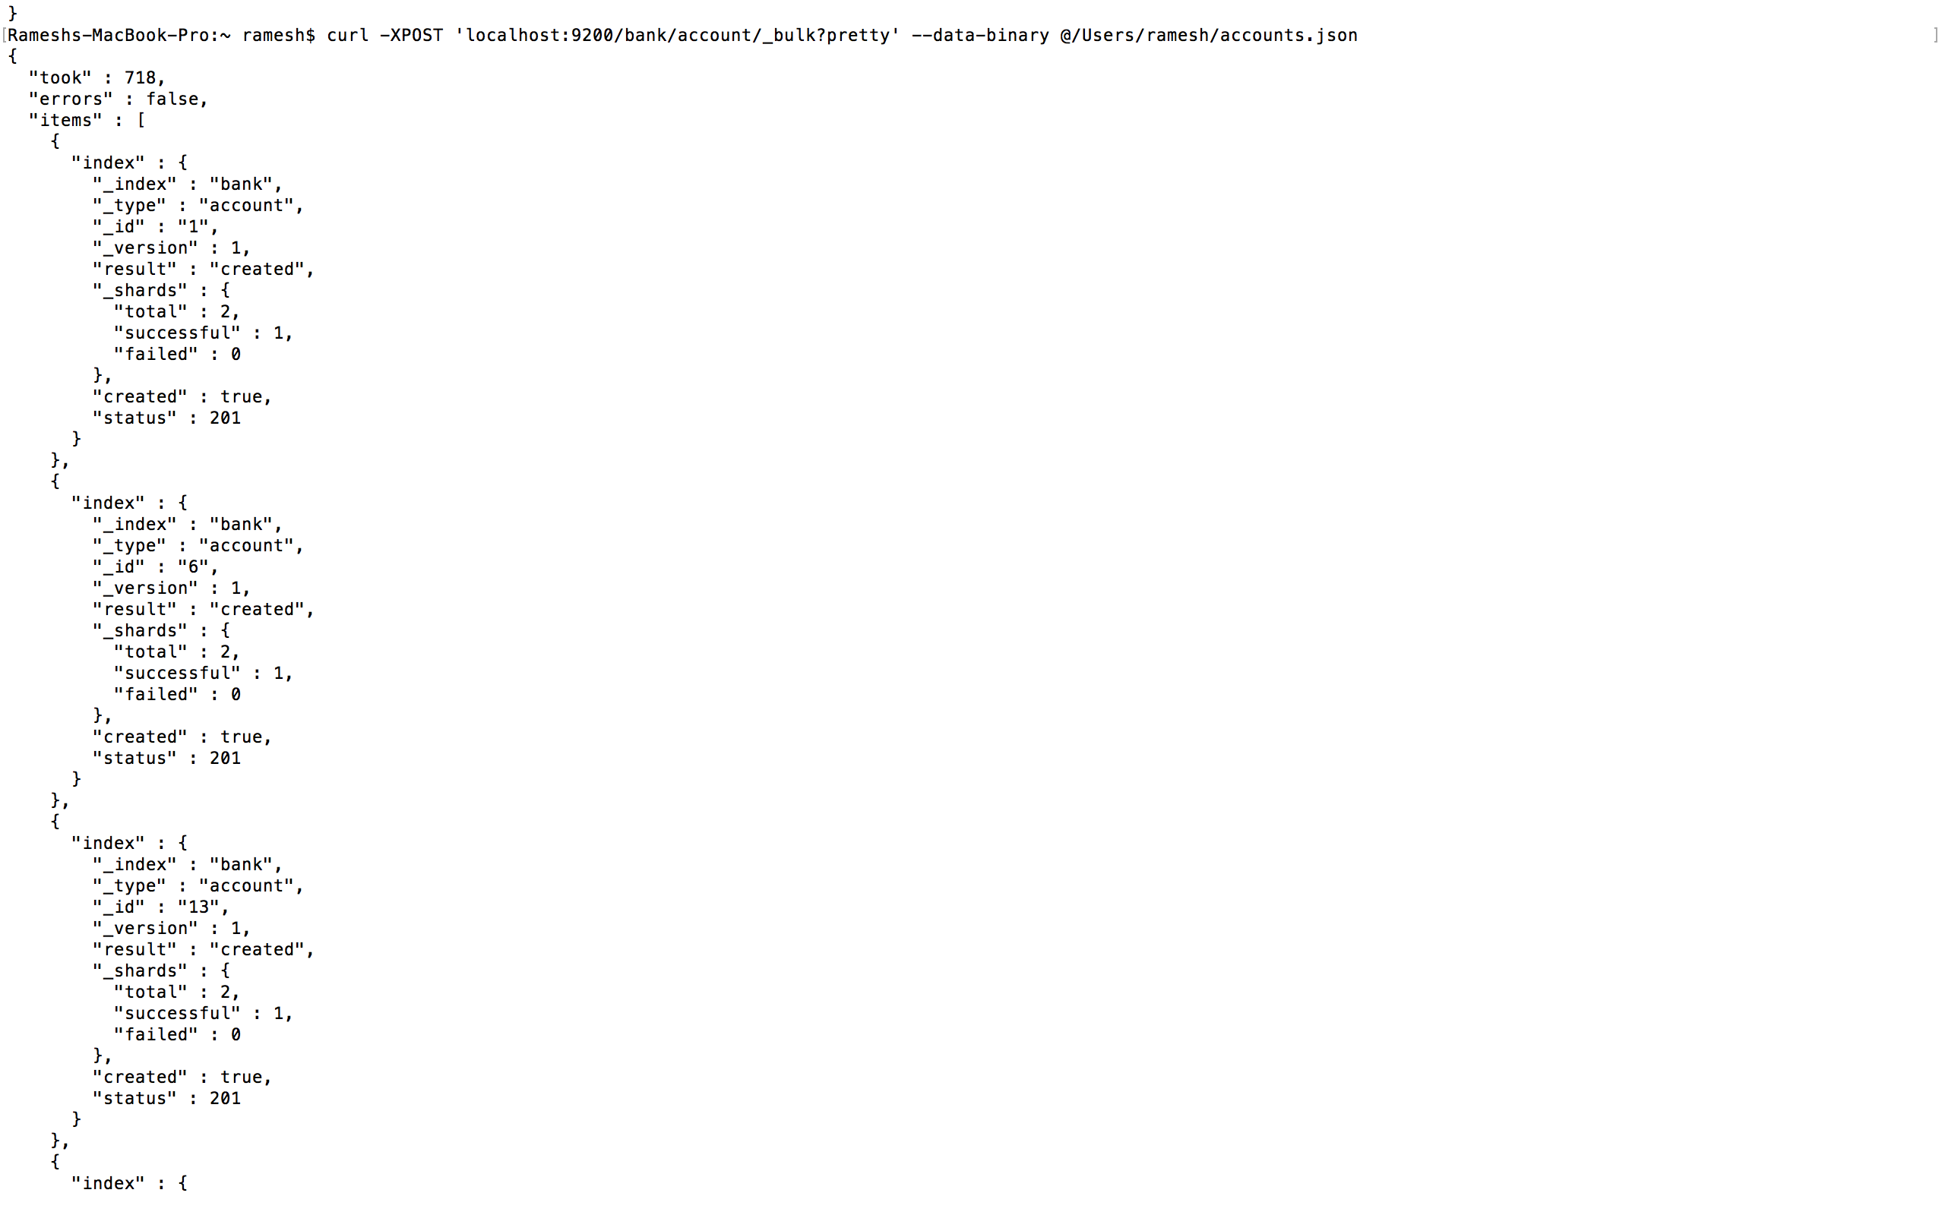

**List all indices in Elasticsearch cluster using REST API DSL Query:**

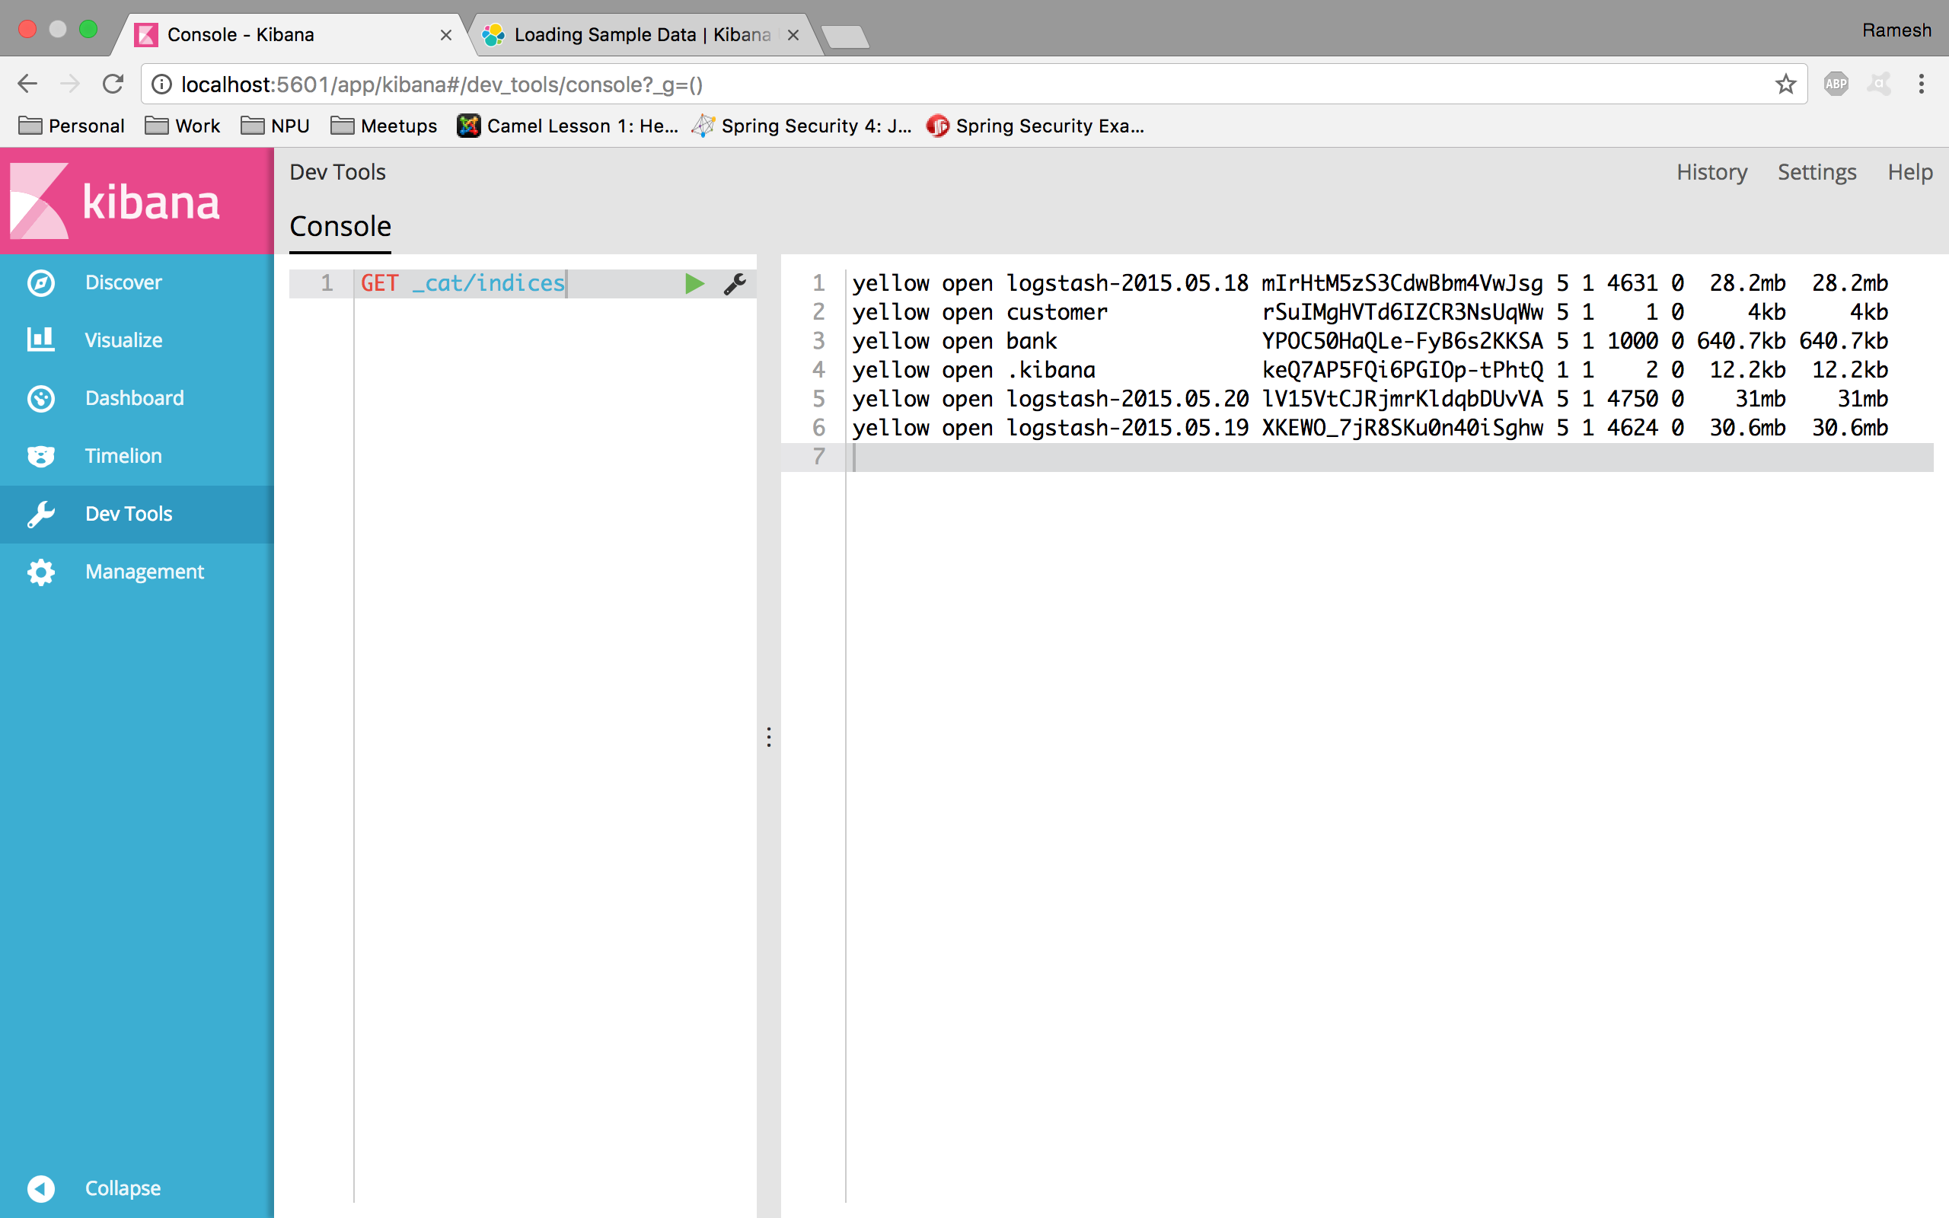

**Log messages count per hour between 17 May 2015 to 20 May 2015:**

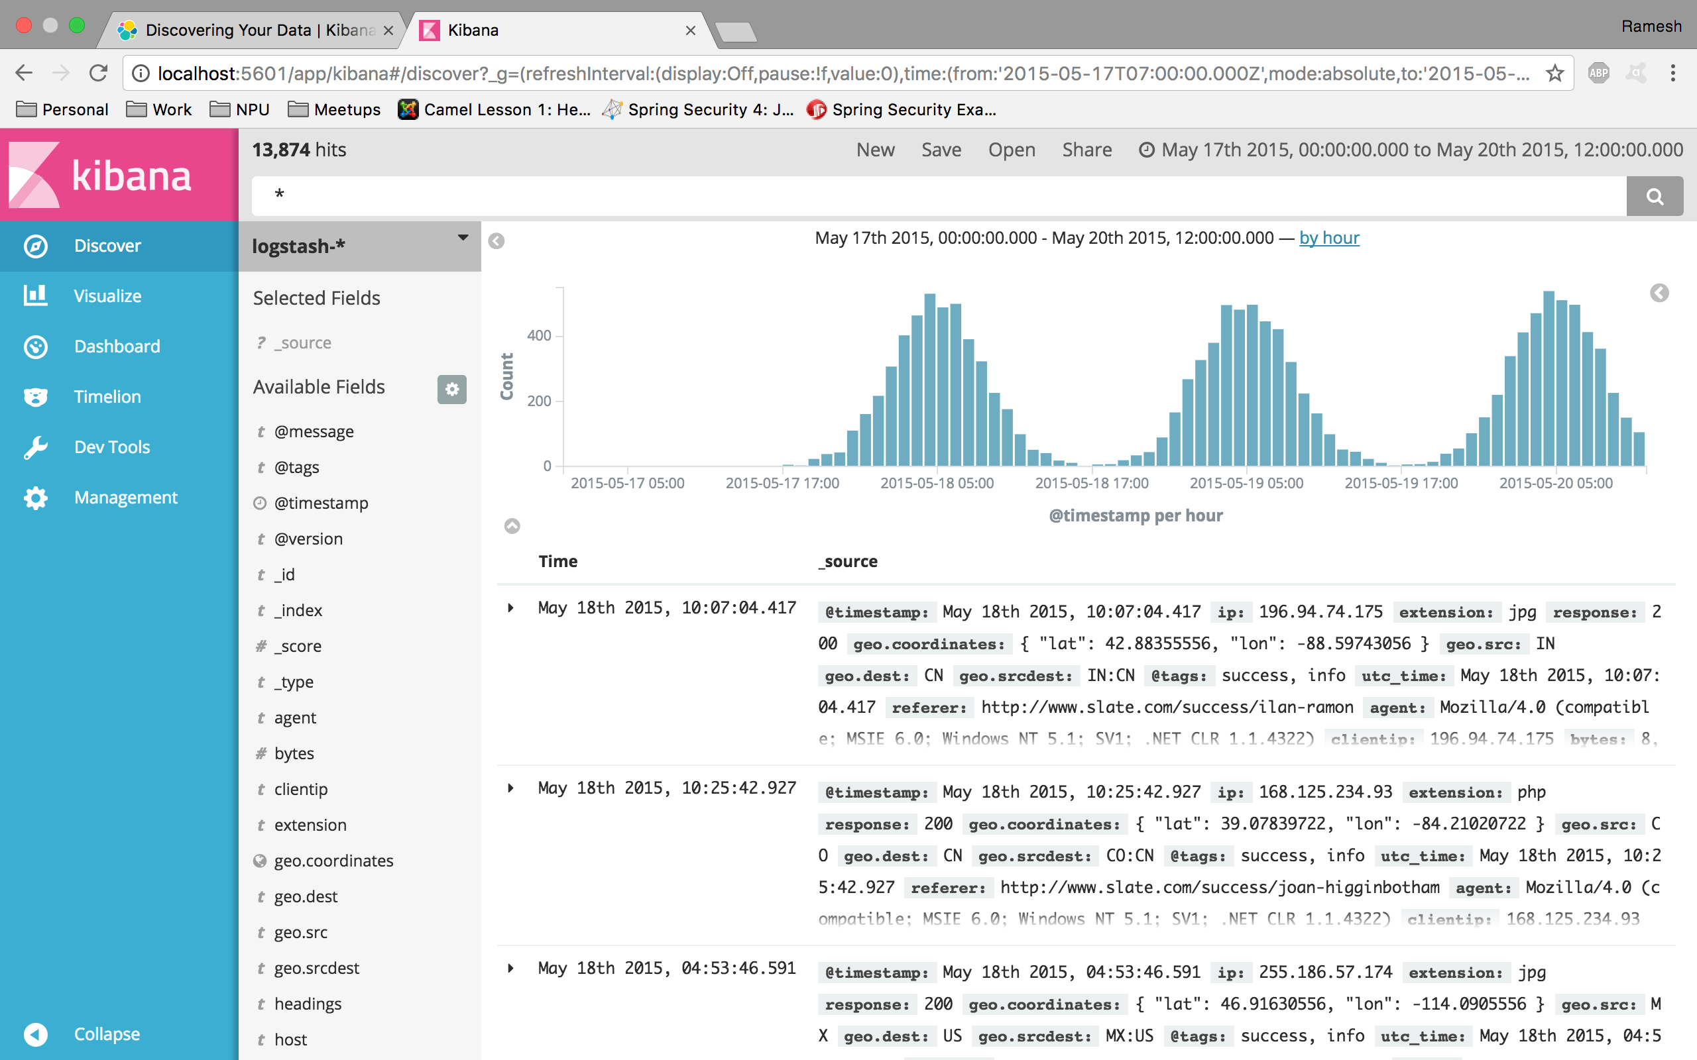

**Accounts where account_number < 50 and balance > 48000:**

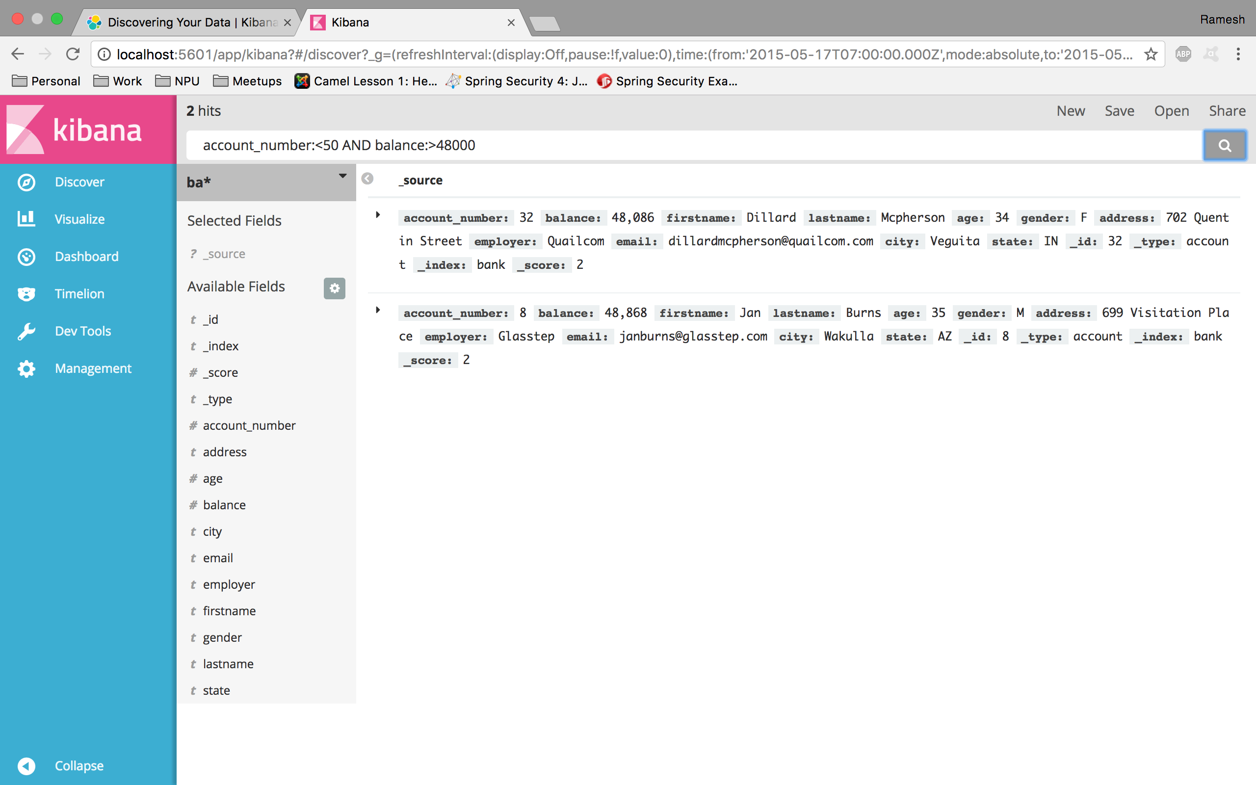

**Pie Chart of accounts according to their balance:**

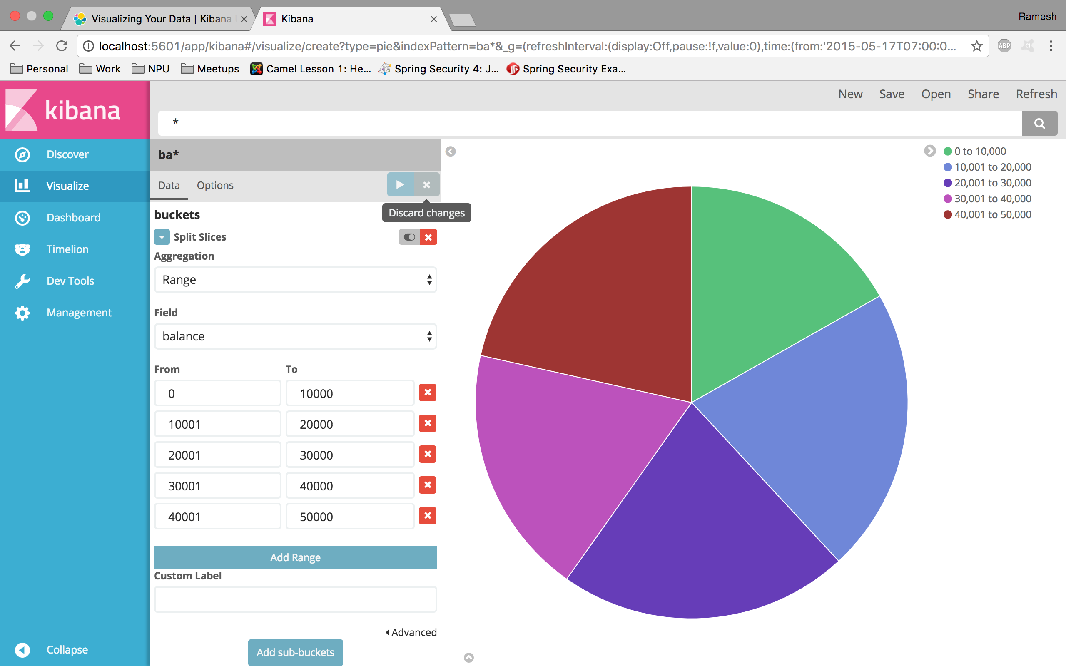

**GeoLocation map of logstash messages:**

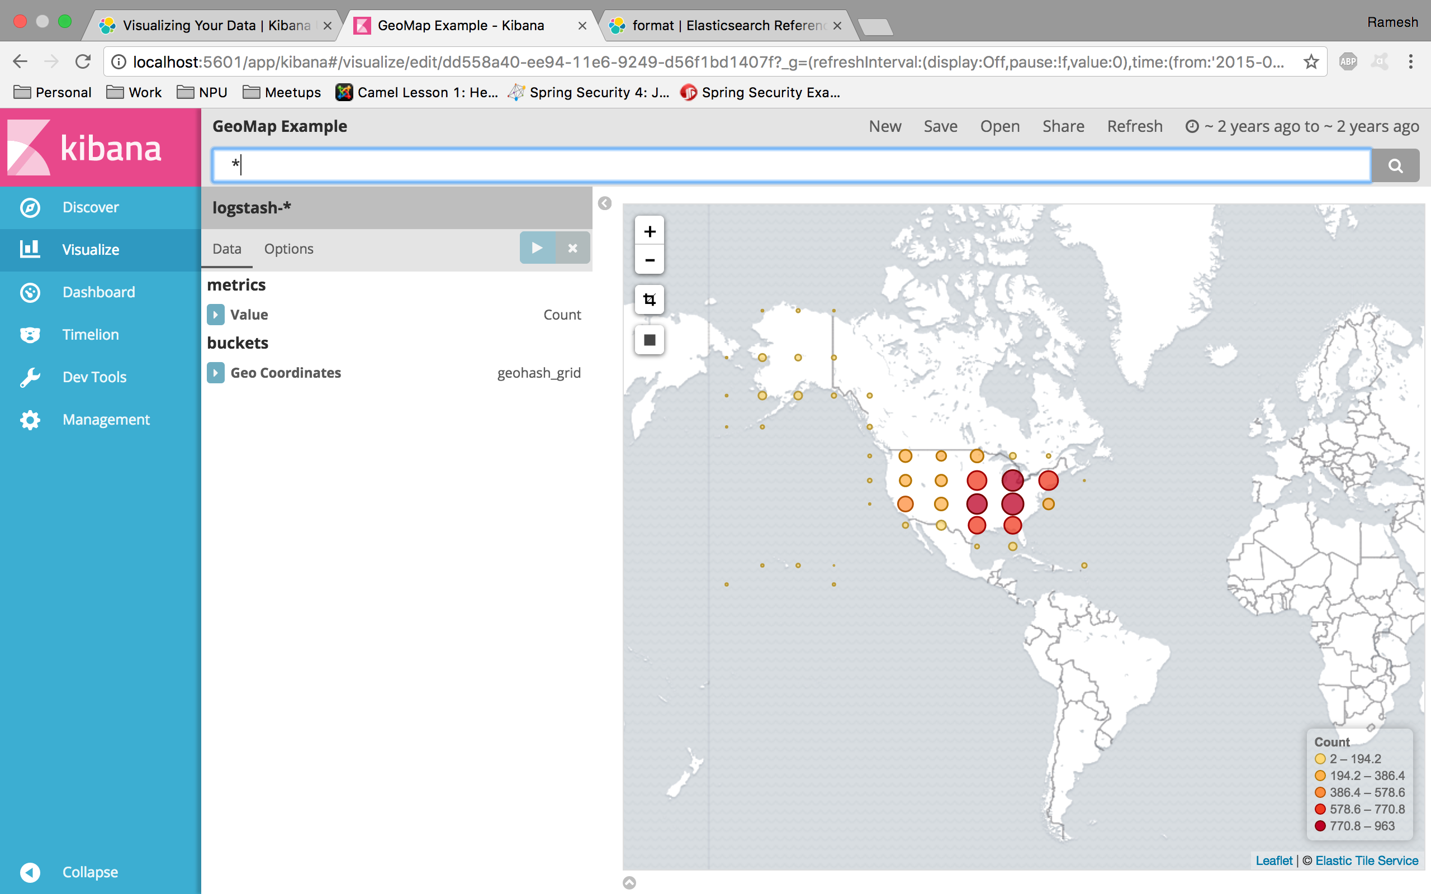

**Dashboard containing Pie chart and Geolocation map created in previous steps:**

